Part 1 – System Design: Transaction Handling System

Table of Contents

1. High-Level Architecture Overview 2

1.1 State Machine Diagram of Transactions 2

1.2 Account Life Cycle Diagram 2

1.3 System sequence of user sending money to another account 3

2. Key Components & Responsibilities 3

3. Data Models 4

4. Technology Choices 4

5. Non-Functional Requirements 5

6. Failure Handling 6

Summary 6

## 1. High-Level Architecture Overview

The system handles **user-initiated transactions** (e.g., sending money, making purchases, or transferring points). It should be **secure**, **reliable**, and **scalable** — suitable for a fintech-style use case.

### 1.1 State Machine Diagram of Transactions

### 1.2 Account Life Cycle Diagram

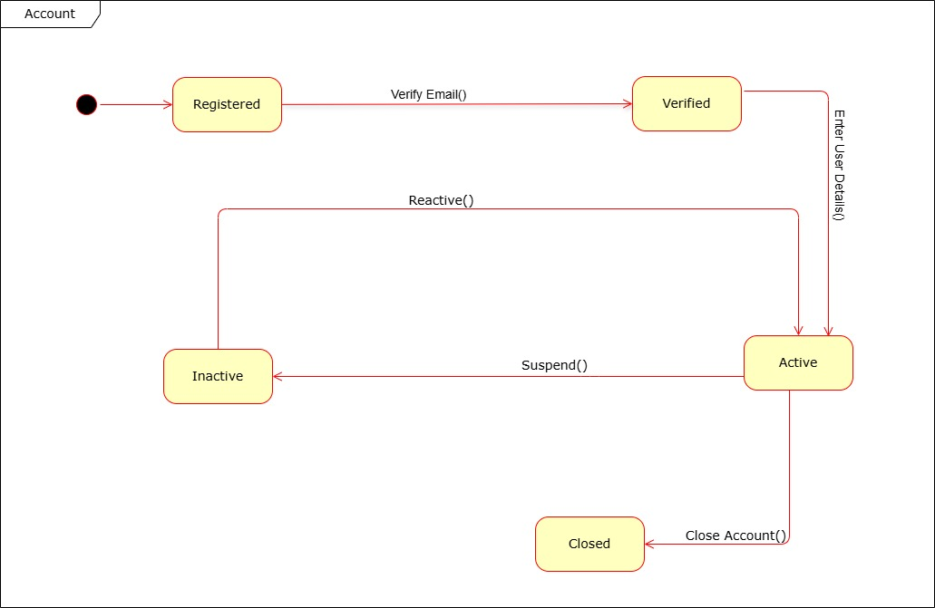

### 1.3 System sequence of user sending money to another account

## 2. Key Components & Responsibilities

| **Component** | **Responsibility** |
| --- | --- |
| **Client App** | Allows users to initiate/view transactions. Handles UI and input validation. |
| **API Gateway** | Routes requests, handles rate limiting, authentication token validation. |
| **Auth Service** | Manages user login, sessions, and JWT tokens. |
| **Transaction Service** | Processes new transactions, deducts balances, ensures atomic DB operations. |
| **Notification Service** | Sends out confirmations via SMS/email. |
| **Database** | Stores users, transactions, audit logs, and balances. |
| **External APIs** | Communicates with payment providers or banks to finalize transactions. |

## 3. Data Models

**🧑‍💻 User**

{

"user_id": "uuid",

"name": "string",

"email": "string",

"password_hash": "string",

"balance": "float",

"created_at": "timestamp"

}

**💳 Transaction**

{

"transaction_id": "uuid",

"sender_id": "uuid",

"recipient_id": "uuid",

"amount": "float",

"status": "pending | success | failed",

"timestamp": "timestamp",

"description": "string"

}

**📝 Record**

{

"log_id": "uuid",

"event": "string",

"user_id": "uuid",

"timestamp": "timestamp",

"metadata": "json"

}

## 4. Technology Choices

|  |  |  |
| --- | --- | --- |
| Layer | Tech Stack | Why? |
| Frontend | React or Flutter | Cross-platform, fast dev cycle |
| API Gateway | NGINX or AWS API Gateway | Routing, throttling, and SSL termination |
| Backend | Node.js (Express) or Python (FastAPI) | Lightweight, async, fast to build |
| Database | PostgreSQL | Relational integrity, supports transactions |
| Auth | JWT with bcrypt | Secure, stateless authentication |
| Notifications | Twilio, SendGrid | Reliable third-party services |
| External APIs | REST over HTTPS | For bank/payment integration |
| Deployment | Docker + AWS ECS or Heroku | Scalable and easy to manage |

## 5. Non-Functional Requirements

**Security**

* Use HTTPS for all comms
* Hash passwords with bcrypt
* Validate and sanitize all inputs
* Use JWT for secure stateless auth
* Store sensitive data encrypted at rest

**Reliability**

* Use transactions in the DB to ensure atomicity
* Retry logic for failed API calls
* Log all events to enable post-mortems
* Health checks + monitoring

**Scalability**

* Stateless backend services behind a load balancer
* Use caching for frequent reads (e.g., Redis)
* Horizontal scaling for both web and DB tiers
* Partition data for high-throughput workloads

## 6. Failure Handling

| **Failure Type** | **How It's Handled** |
| --- | --- |
| **External API fails** | Retry logic + circuit breaker fallback |
| **DB write fails** | Rollback transaction + return meaningful error |
| **Auth token invalid** | 401 Unauthorized + redirect to login |
| **Rate-limiting triggered** | 429 Too Many Requests with retry-after headers |
| **Unexpected crash** | Error logged + monitoring alert (via Datadog/Sentry/etc.) |

## Summary

This system is designed to be **modular**, **secure**, and **scalable**. Each service has a clear role, and the architecture supports growth and real-world challenges like third-party failures and high traffic. Technologies are chosen for developer speed and long-term maintainability.